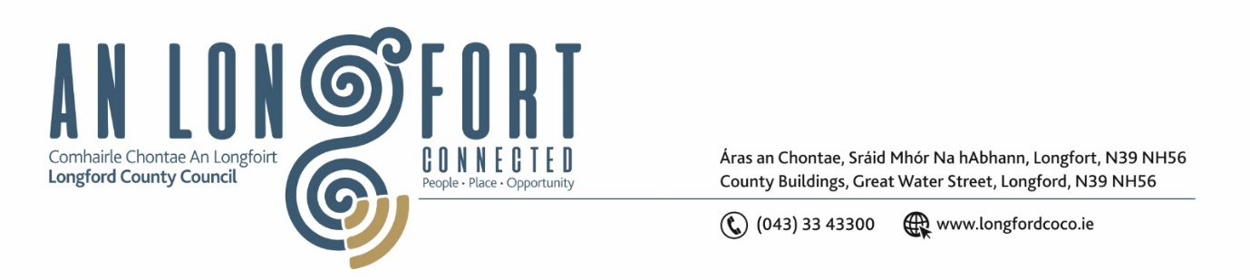

**GRANARD MUNICIPAL DISTRICT**

***Please note meeting will be held in Granard Library.***

**18 September 2023.**

**To: Each Member of Granard Municipal District.**

**Dear Member,**

You are requested to attend a Meeting of Granard Municipal District to be held in Granard Library on **Tuesday 26th September 2023 at 3.30pm** to transact business, as set out on the Agenda hereunder.

**Yours sincerely**,

______________________

**Claire McNabola,**

**Meetings Administrator**

**AGENDA**

Prayer before meeting.

**Presentation on the Draft LECP**

**1.** Confirmation of Minutes as follows: -

1. Granard Municipal District Meeting held on 25 July 2023 – enclosed.

**2.** Matters arising from Minutes.

**3.** Declaration of Interest by Members.

**4.** Management Report incorporating Area Engineer’s Progress Report - enclosed

**5.** Recommendation from Place Naming Committee - Plaque in memory of General Humbert in the Garden of Remembrance, Ballinamuck.

**6.** Recommendation from the Place Naming Committee – Plaque in Memory of Private Patrick Kelly

**7.**Special Projects/Discretionary Grants 2023

**8.** Consideration of request from Gaels United FC in relation to Drumlish Christmas Market – enclosed

**9.** Notices of Motions, submitted by Councillors, as listed hereunder:

**Councillor Colin Dalton**

1. I call on Longford County Council to erect a sign as Esker Cross and Mallon’s Cross with directions to Cairn Hill
2. I call on Longford County Council to look in to refreshing the wooden fence and wooden area in the playground in Ballinalee
3. It’s hedge cutting session again so we need to get it out there to land owners to cut their hedges and leave our road safer for all users.

**10. Correspondence**

1. Correspondence received from Minister for Justice re. policing in Longford